Basic Resume Web Page Walkthrough

STEP 1:

You will begin your resume webpage by creating an HTML file. Do this by adding an opening and closing HTML tag to your code.

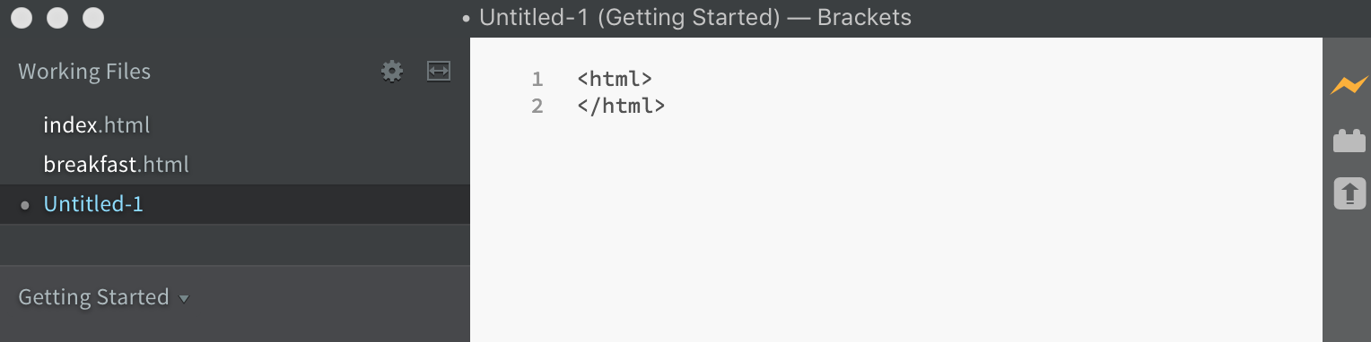

STEP 2:  
Save your file as an HTML document, making sure to add .html to the end of the file name.

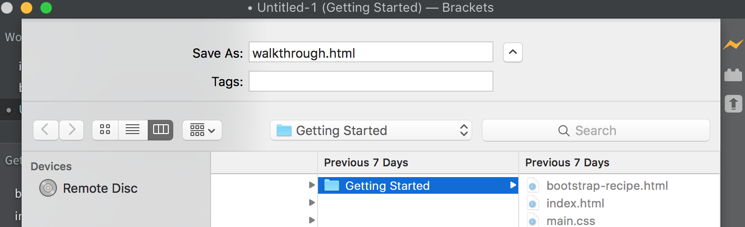

STEP 3:

Now we begin to form the body of the actual webpage. Begin by adding a header to your webpage by using one of the H1-H6 header tags. This header will be your first and last name.

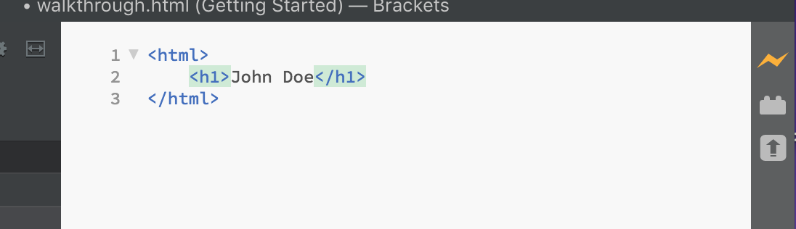

STEP 4:

Next we will begin adding the subheadings of the resume webpage. Begin by adding one of the smaller header tags than you used for your first and last name. For example, if you used H1 as the header sizing for your name, you would need to use one of the H2-H6 tags depending upon the size of the font you will be using.

Make a sub heading for each of the sections of your resume. Here we will be using a sub heading for Objectives, Experience, Education, and Skills.

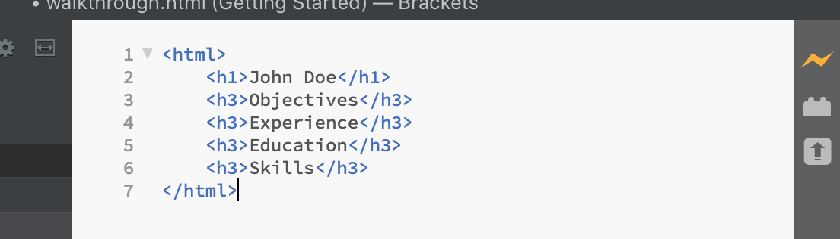

STEP 5:

We will now begin filling in each of the sections of the resume. For the Objectives section, we will be adding a simple paragraph to summarize our overall goals. Do this by adding an opening and closing paragraph tag (<p></p>) and filling in your information between the brackets.

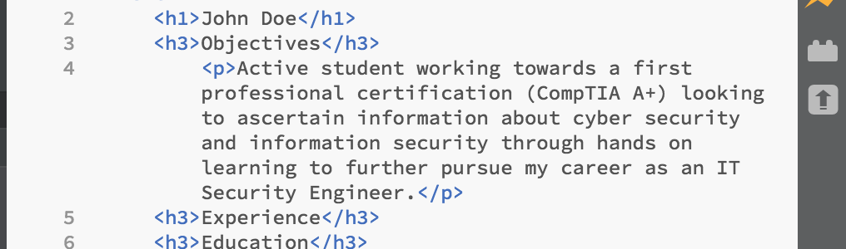

For the experience, education, and skills sections we will use an unordered list to fill in these sections in order to create a more organized look to the webpage.

Start by adding the opening and closing unordered list tag to the experience and skills section.



Next, create your list items by adding the opening and closing <li> tag to each of your bullet point items. This will ensure your list items are properly separated and will also give distinction to the bulleted items.

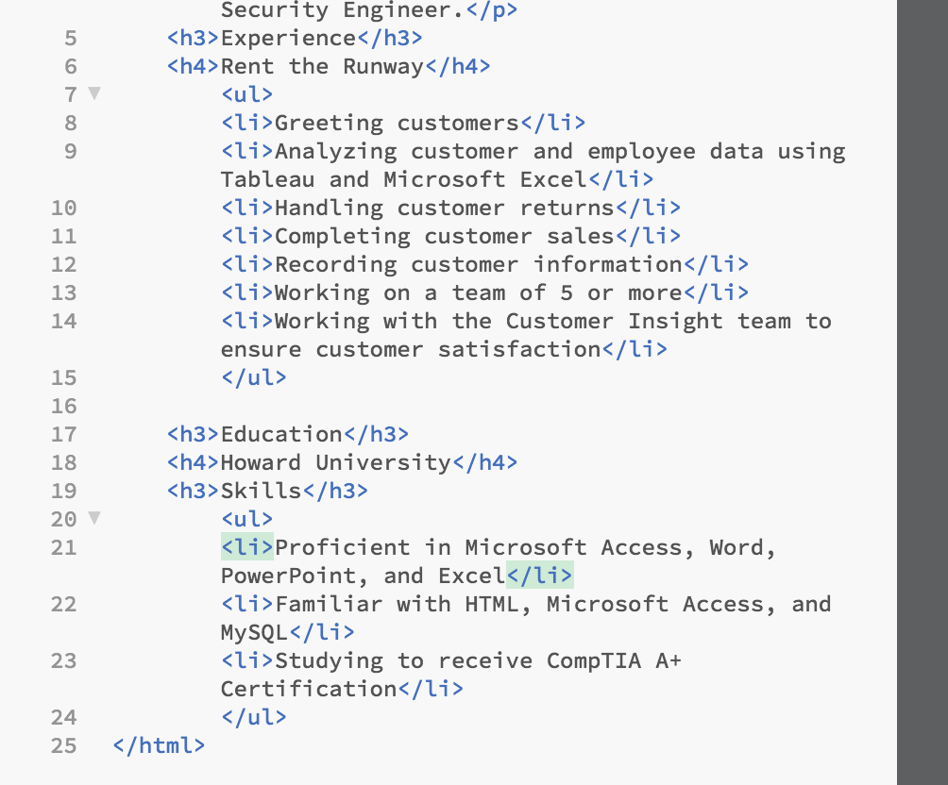

For the Experience and Education sections, be sure to add a sub-sub heading right underneath where you added the tag for the sub heading in order to distinguish the place of work and your school if applicable.



At this point your webpage should look something like this:

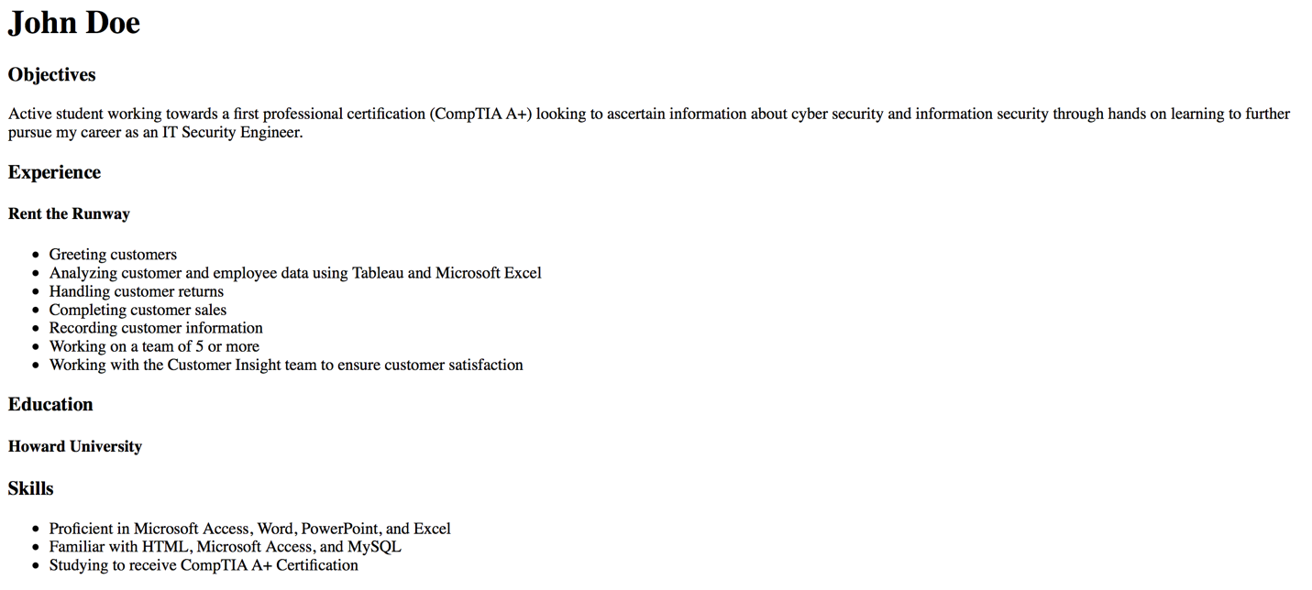

STEP 6:

Add opening and closing paragraph tags to the Education sub-sub heading and fill in with your start and end date as well as your field of study.

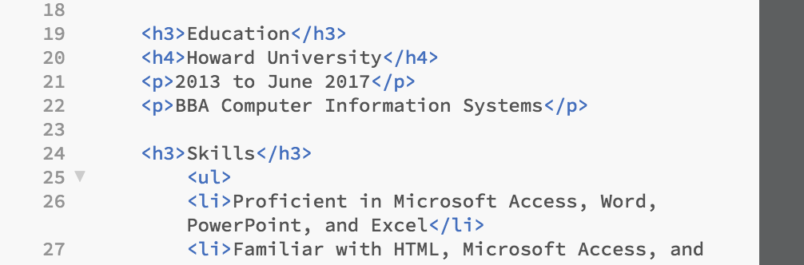

STEP 7:  
now we will begin making the webpage links to jump to the different sections without having to manually scroll all the way down.

First we will add reference names to each of the sub headings. For each sub heading, add a reference tag with a reference name for each sub heading. This reference name does not have to be the exact same as your sub heading, but whatever it is it will need to be the same later on when we are adding the actual links on the webpage; for example ( <a name= “objectives”> Objectives </a>). Note: when making the reference name, be sure to add quotations to the beginning and end of the name.

Add these tags inside of the sub heading tags (H3 in this case).

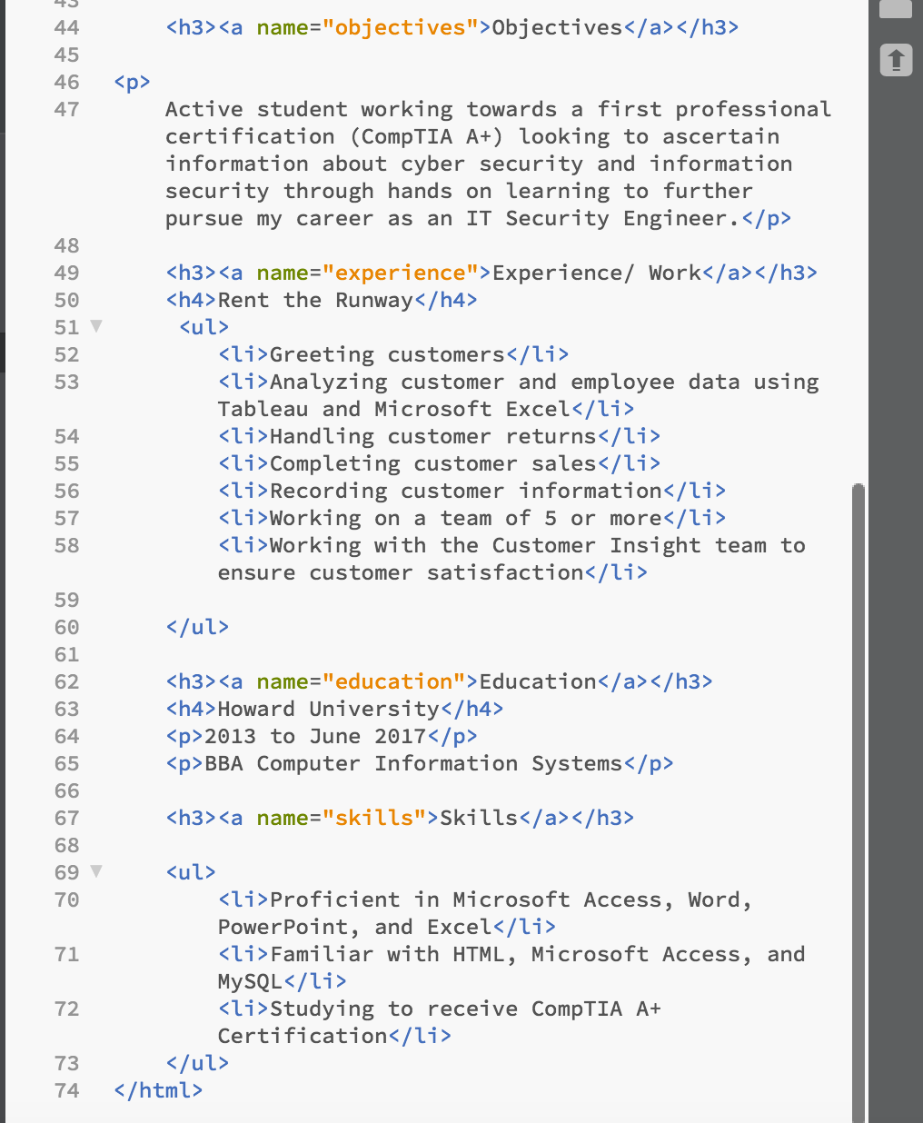

STEP 8:

It is now time to add the actual links to the webpage. At the top of your code right underneath the beginning HTML tag and right before your header name, add one of the header tags. This header tag will dictate the size of your links (in this case H4 is used).

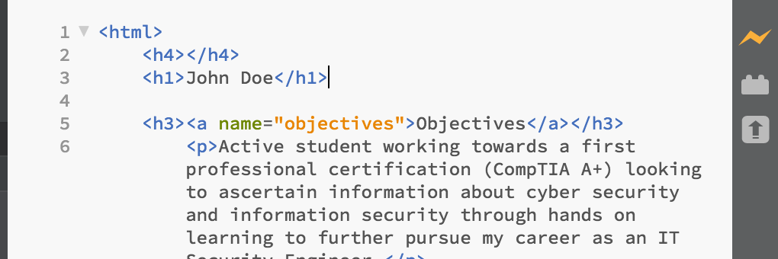

STEP 9:

Between the new tags you just added to the webpage is where you will write the code for the links on the webpage. Begin by adding hyper-reference tags in between the header tags you just added. After the equal sign of the reference tag, in quotations type the name you gave the sub headings when you formulated the reference tags for them, being sure to include a pound (#) sign before the given name to indicate the link destination is on the same webpage.

End the algorithm with the closing “</a>” tag.

For example, (<a href=”#objectives”>Objectives</a>).

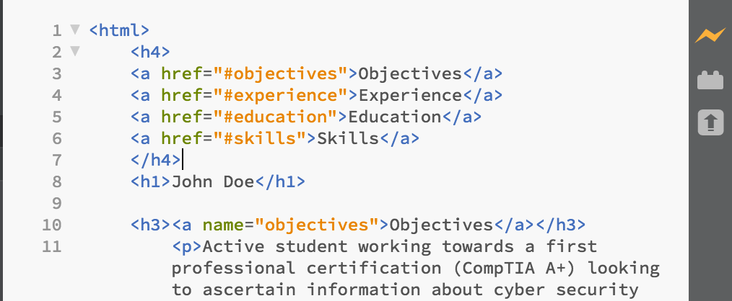

At this point you should have a website with fully functional links.

STEP 10:

The final step is to stylize your resume. Here we will be using a little bit of CSS in order to make this happen. Start by adding an opening and closing header tag right underneath the opening HTML tag.

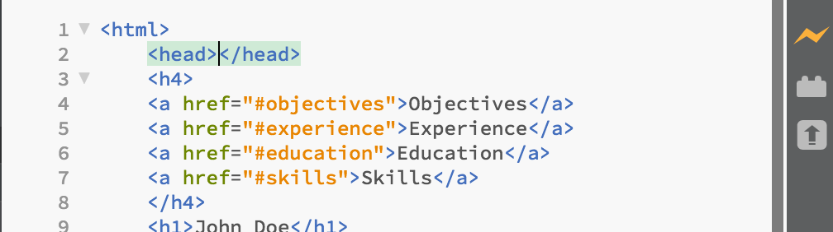

between this header tag add the opening and closing <style> tag. This will ensure the recognition of the CSS code.

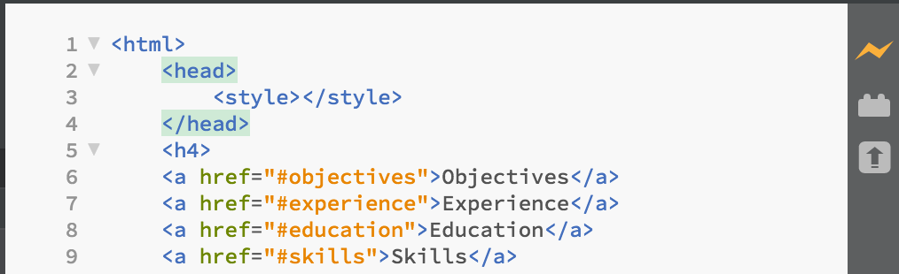

In this resume, we want our name and the links to be centered at the top of the webpage.

To do this using CSS add the style code between the <style> tags in order to center the text. Note: CSS code begins and ends with {} instead of the traditional <>.

We will be doing this for both the main header (your name) as well as the links we added (H4 in this case).

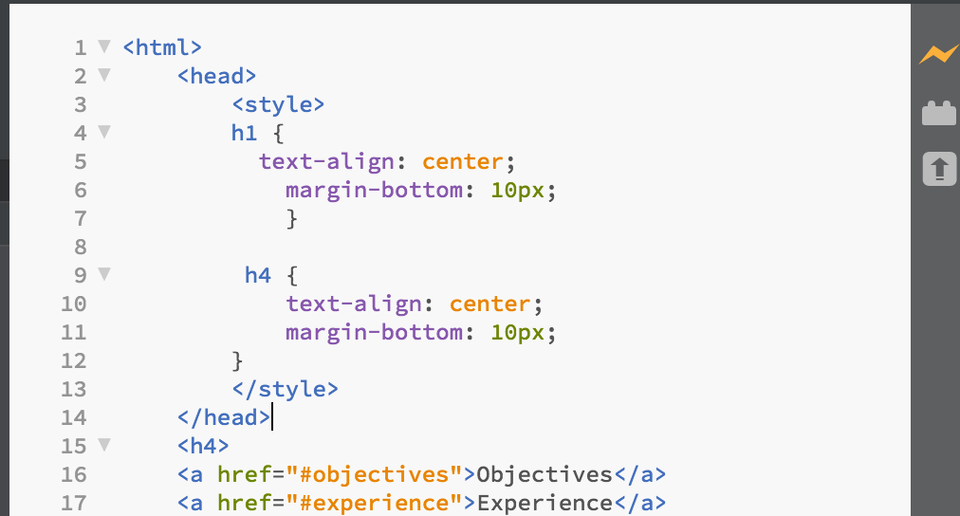

Once your basic resume webpage is complete it should look something like this:

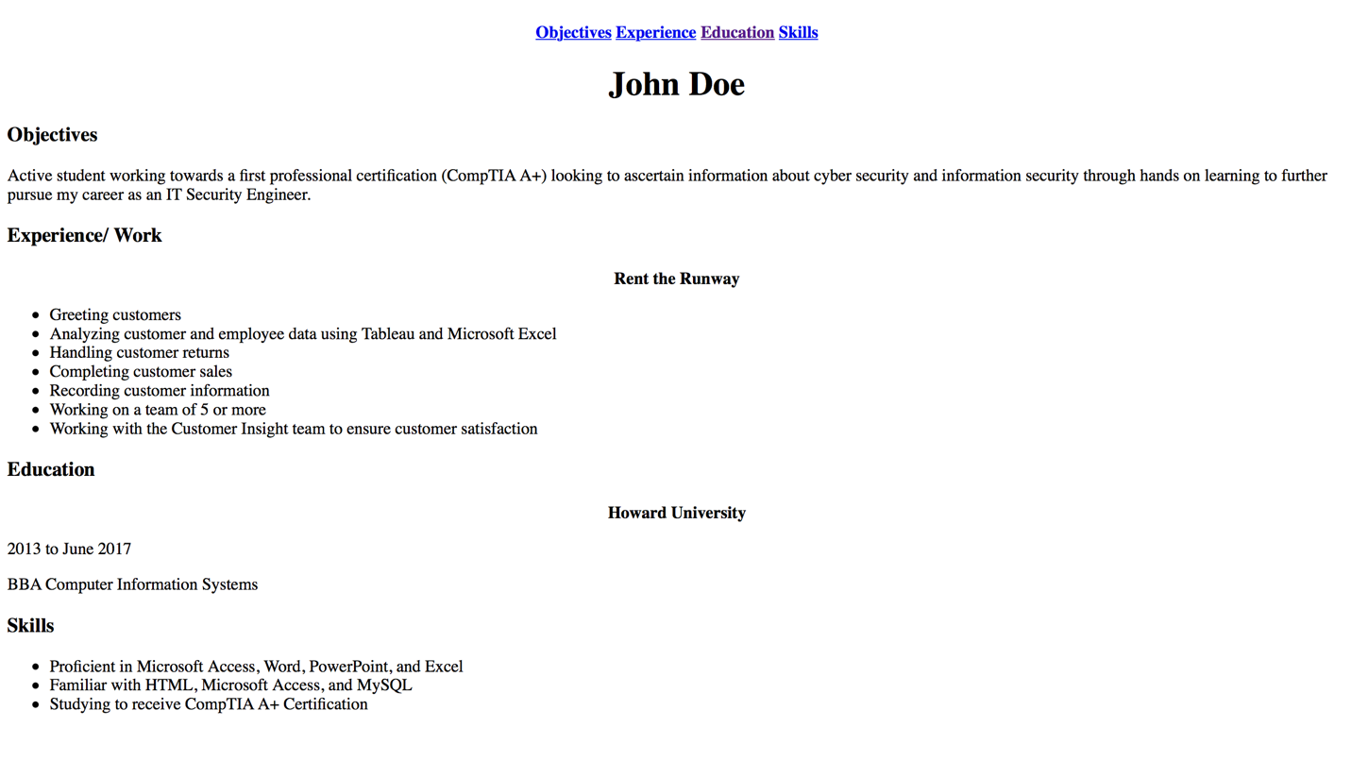

And that’s it!!

You have now successfully created a working basic resume webpage!